**Release and Sprint Plans**

**Team Number**

|  |  |
| --- | --- |
| **Student Number** | **Team Member Name** |
| n7007035 | Tom Burke |
| n9017097 | Scott Fletcher |
| n9284877 | Steve Fiedler |
| n9166629 | Travis Dalton |
| n9177493 | Bradley Zaal |

Tutor: Artem Kulakov

Version:

Date:

Link to Github Repository: <https://github.com/freef49/IFB299-Music-School/tree/master>

**Release 1**

Delivery date: 22nd September                                                                                                            Total Story Points: **41**

Release 1 is an important stepping stone in the development of the Mika Williams Music School website. The two features that will be focused on for Release 1 are Accessibility and Account administration. Most of the sprint time available will be spent developing the accessibility feature as it has a higher story point count then Account Administration. The goals of this release is to present the core features of the website completed and usable so that the client can clearly see their vision.

**Accessibility - Sign up/Login**

Accessibility is a very important aspect to any website or application. In order to promote a strong user experience and allow as many potential users to easily access the website it is key that accessibility is one of the main features focused on in the development period. The business value of Accessibility is the potential for a strong user experience, an experience that they might recommend to others, thus increasing potential traffic to the website. Using a website will little to no accessibility would negatively impact the user experience of the website.

|  |  |  |
| --- | --- | --- |
| **Story ID** | **Story Title** | **Story Points** |
| **12** | Teacher Registration | 2 |
| **14** | Student Registration (Including Login details of Parents) | 4 |
| **44** | Admin/Owner Login | 8 |
| **2** | Student Login | 8 |
| **6** | Teacher Login | 8 |
|  | Story Point Sub-Total: | 30 |

**Account Administration - Updating/Blocking Users**

Account Administration is the core of any login based website. Giving users the ability to manage their account will again provide a strong user experience by allowing them to update or change information easily. It also promotes security as it allows the blocking of certain users by the owner, who pose a security threat. The business value can clearly be seen as Account Administration is considered a highly important aspect of any website, and having this ability will promote the website as a safe and secure place.

|  |  |  |
| --- | --- | --- |
| **Story ID** | **Story Title** | **Story Points** |
| **17** | Teacher View/Edit details | 4 |
| **27** | Owner Remove Teacher/Student | 1 |
|  | Story Point Sub-Total: | 5 |

**Features Pulled from release 2**

Stories pulled into sprint 2 due to underestimation of velocity.

|  |  |  |
| --- | --- | --- |
| **Story ID** | **Story Title** | **Story Points** |
| **51** | Student View/edit details(story created) | 4 |
| **15** | Link to Facebook Page ib (pulled from release 2) | 1 |
| **42** | Google Maps on the Webpage  (pulled from release 2) | 1 |
|  | Story Point Sub-Total: | 6 |

**Release 2**

Delivery date:  27 October                                                                                                     Total Story Points: **86**

Release 2 is of pivotal importance to the final project. Following the main functionality of Release 1, Release 2 will focus on the core features and requirements of the website. The second release will focus on the main feature of the website in the form of timetabling and the front end of the website. The sprint time will equally be shared between the two tasks as they are of equal story point importance. The goal of this Release will be to provide the teachers and students with the bread and butter of their use experience as well as to provide the website with its core usability and aesthetics.

**Timetabling**

Timetabling will be the core user experience for most teachers and students. This feature will give them the ability to change availability, see who their teachers are, see when their classes are scheduled and give students the ability to book sessions in the schools facilities. This feature will be the bread and butter of day-to-day operations with other features being added to this in further releases.

|  |  |  |
| --- | --- | --- |
| **Story ID** | **Story Title** | **Story Points** |
| **5** | Timetabling for the Teacher | 32 |
| **16** | Student View Timetable | 16 |
| **25** | Book Session in Free Play Room | 16 |
| **4** | Student Book a lesson | 16 |
| **11** | Teacher Edit Availability | 2 |
| **4** | Owner book interview | 4 |
|  | Story Point Sub-Total: | 86 |

**Release 3**

Delivery date:                                                                                                         Total Story Points: **50**

Release 3 can be seen as an expansion of the websitesites feature set. Whilst not a part of core set of features that were seen in Release 1 and 2, the features in Release 3 are features that can increase the business value of the website as user will be able to access various management features from the website instead of in person. It will also allow for strong communication between various users of the website through email. The goal of Release 3 is to have an instrument management system that can be accessed by differently depending on the role of the user, and for strong email communication between students/parents and teachers.

**Instrument Management**

Instrument management, for a music school, is a highly important feature. Many student wishing to learn an instrument may not have access to that particular instrument. Mika Williams school will allow students to hire out instruments on site to alleviate this problem. However this means that these instruments need system built around them to allow them to be easily managed. This includes reports about instruments for the owner, costs for the student to hire them out, and logging and storing information about the instruments. This feature will definitely increase the business value of the website, as it allows student with no access to a musical instrument to still learn and perform with a particular instrument.

|  |  |  |
| --- | --- | --- |
| **Story ID** | **Story Title** | **Story Points** |
| **8** | Owner Instrument Condition Report | 8 |
| **9** | Owner Instrument Use Report | 8 |
| **10** | Instrument Maintenance Costs | 8 |
| **34** | Instrument Logging | 16 |
|  | Story Point Sub-Total: | 40 |

**Emailing**

Interaction between students/parents and teachers is a highly important aspect of any educational environment. It allows feedback about the skills and techniques learnt, assessment dates, class changes and much more to be communicated. The best way to facilitate this through an IT solution is emailing. Whilst emailing is important, it is also important to allow users to opt out of receiving emails for their own personal reasons. The business value is no doubt increased with the use of emailing between users, as the promote a strong educational environment to facilitate learning.

|  |  |  |
| --- | --- | --- |
| **Story ID** | **Story Title** | **Story Points** |
| **29** | Student Choose to Receive Emails | 2 |
| **30** | Parent Choose to Receive Emails | 2 |
| **36** | Teacher Emailing Owner about Students | 2 |
| **47** | Optional Email Registration form for Parents | 4 |
|  | Story Point Sub-Total: | 10 |

**Delivery Schedule**

|  |  |  |  |  |  |  |  |  |
| --- | --- | --- | --- | --- | --- | --- | --- | --- |
| Week 6 | Week 7 | Week 8 | Week 9 | Week 10 | Week 11 | Week 12 | Week 13 |  |
| Sprint 1 | | Sprint 2 | | Sprint 3 | | Sprint 4 | |  |
| Release 1 | | | | Release 2 | | | | |

|  |  |  |  |  |  |  |  |
| --- | --- | --- | --- | --- | --- | --- | --- |
| Week 14 |  | Week 15 |  |  |  |  |  |
| Sprint 5 | | … | |  | |  | |
| Release 3, 4, … | | | | | | | |

Estimated Velocity:

**Sprint 1 : Accessibility**

Total Story Points: 22                                                                                                Total Hours: 34

Current Velocity: Undefined

**ID 12: Teacher Registration**

|  |  |  |  |
| --- | --- | --- | --- |
| **Task ID** | **Task Description** | **Estimate** | **Taken** |
| **1** | Generating the user model (teacher) | 3 | 5 |
| **2** | Adding validations | 2 | 0.5 |
| **3** | Ensuring a secure password | 4 | 2 |
| **4** | Verify story is complete (acceptance test) | 1 | 0.5 |
|  | Story Points: 2                                                                                               Total Hours: 8 |  |  |

**ID 14: Student Registration**

|  |  |  |  |
| --- | --- | --- | --- |
| **Task ID** | **Task Description** | **Estimate** | **Taken** |
| **5** | Generating the user model (student) | 1 | 3 |
| **6** | Adding validations | 2 | 0.5 |
| **7** | Ensuring a secure password | 2 | 1 |
| **8** | Adding additional fields for younger students | 2 | 1 |
| **9** | Verify story is complete (acceptance test) | 1 | 1 |
|  | Story Points: 4                                                                                               Total Hours: 6.5 |  |  |

**ID 2: Student Login**

|  |  |  |  |
| --- | --- | --- | --- |
| **Task ID** | **Task Description** | **Estimate** | **Taken** |
| **10** | Setup the environment | 2 | 3 |
| **11** | Generate Resources | 2 | 1 |
| **12** | Build automated testing platform | 2 | 5 |
| **13** | Style Login page | 1 | 1 |
| **14** | Set required fields | 1 | 1 |
| **15** | Verify story is complete (acceptance test) | 1 | 0.5 |
|  | Story Points:  8                                                                                              Total Hours: 11.5 |  |  |

**ID 6: Teacher Login**

|  |  |  |  |
| --- | --- | --- | --- |
| **Task ID** | **Task Description** | **Estimate** | **Taken** |
| **16** | Setup the environment | 2 | 2 |
| **17** | Generate Resources | 2 | 2 |
| **18** | Configure Automatic testing platform | 2 | 3 |
| **19** | Style Login page | 1 | 0.5 |
| **20** | Set required fields | 1 | 0.5 |
| **21** | Verify story is complete (acceptance test) | 1 | 1 |
|  | Story Points:     8                                                                                           Total Hours: 9 |  |  |

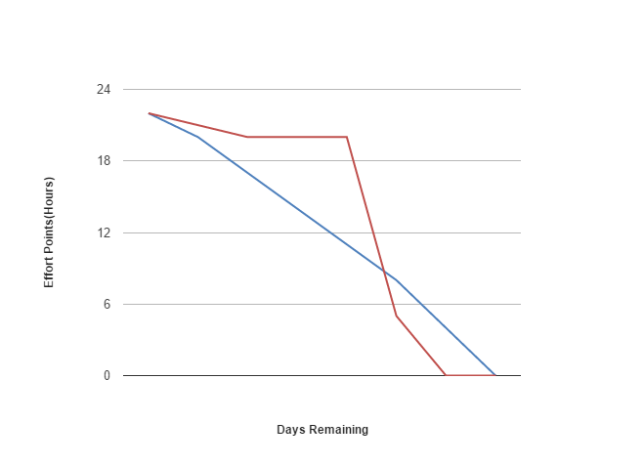

**Sprint 2 : Account Administration/Features Pulled from Release 2**

Total Story Points: 20                                                                                                Total Hours: 34.5

Current Velocity: 0.65 story points an hour.

**ID 17: Teacher View/Edit details**

|  |  |  |  |
| --- | --- | --- | --- |
| **Task ID** | **Task Description** | **Estimate** | **Taken** |
| **1** | Generate page to edit details | 2 | 1 |
| **2** | Add form to page | 2 | 2 |
| **3** | Add functionality | 4 | 6 |
| **4** | Verify story is complete (acceptance test) | 1 | 1 |
|  | Story Points: 1                                                                                               Total Hours: 10 |  |  |

**ID 27: Owner Remove Teacher/Student**

|  |  |  |  |
| --- | --- | --- | --- |
| **Task ID** | **Task Description** | **Estimate** | **Taken** |
| **5** | Functionally to check if owner | 1 | 1 |
| **6** | Add html button | 1 | 1 |
| **7** | Add functionality on press remove user from database | 0.5 | 0.5 |
| **8** | Verify story is complete (acceptance test) | 1 | 1 |
|  | Story Points: 1                                                                                             Total Hours: 3.5 |  |  |

**ID 51: Student View/edit details**

|  |  |  |  |
| --- | --- | --- | --- |
| **Task ID** | **Task Description** | **Estimate** | **Taken** |
| **9** | Generate page to edit details | 2 | 1 |
| **10** | Add form to page | 2 | 2 |
| **11** | Add functionality | 4 | 6 |
| **12** | Verify story is complete (acceptance test) | 1 | 1 |
|  | Story Points:  8                                                                                              Total Hours: 10 |  |  |

**ID 15: Link to Facebook Page**

|  |  |  |  |
| --- | --- | --- | --- |
| **Task ID** | **Task Description** | **Estimate** | **Taken** |
| **13** | Add link on home page | 1 | 1 |
| **14** | Verify story is complete (acceptance test) | 1 | 1 |
|  | Story Points:     1                                                                                         Total Hours: 2 |  |  |

**ID 42: Google Maps on the Webpage**

|  |  |  |  |
| --- | --- | --- | --- |
| **Task ID** | **Task Description** | **Estimate** | **Taken** |
| **15** | Add link on home page | 1 | 1 |
| **16** | Verify story is complete (acceptance test) | 1 | 1 |
|  | Story Points:     1                                                                                          Total Hours: 2 |  |  |

**ID 44: Admin/Owner Login**

|  |  |  |  |
| --- | --- | --- | --- |
| **Task ID** | **Task Description** | **Estimate** | **Taken** |
| **17** | Setup the environment | 2 | 2 |
| **18** | Generate Resources | 2 | 2 |
| **19** | Configure Automatic testing platform | 2 | 3 |
| **20** | Style Login page | 1 | 0.5 |
| **21** | Set required fields | 1 | 0.5 |
| **22** | Verify story is complete (acceptance test) | 1 | 1 |
|  | Story Points:     8                                                                                           Total Hours: 9 |  |  |

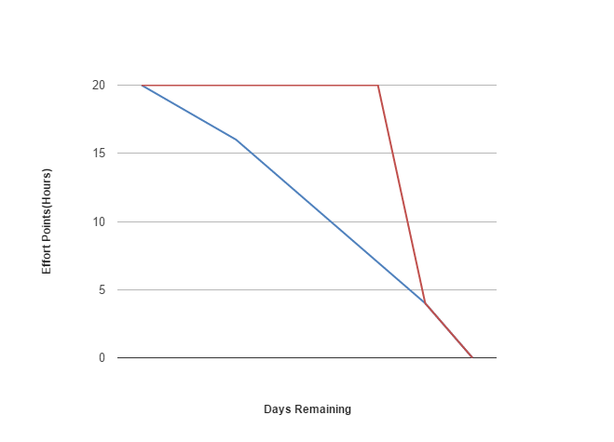

**Burn Down Chart**

